**Single linked list**

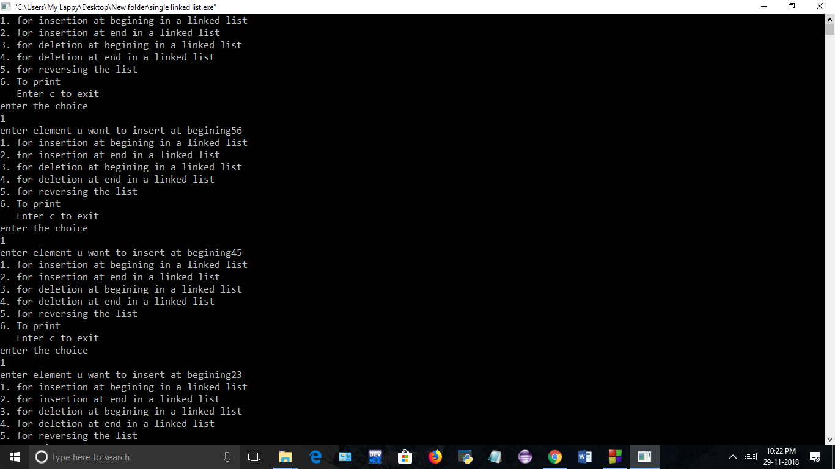

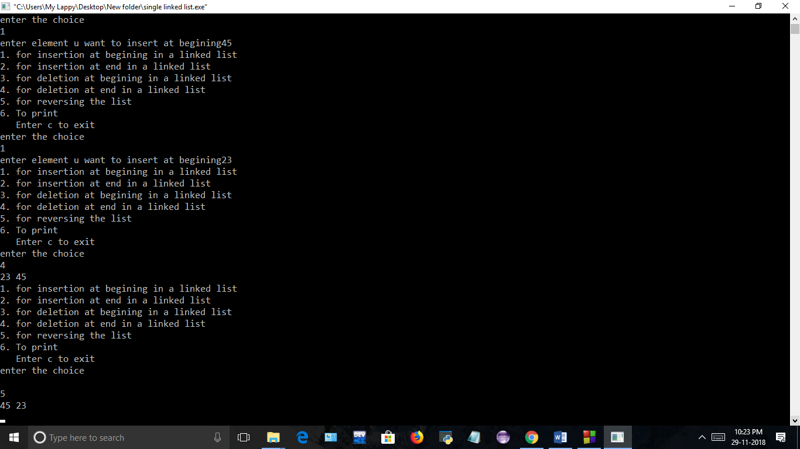

**Single linked list(using structure in class)**





**Single linked list(using class and structure)**





**Single linked list(using class)**



